**Project Design Phase-I** - **Solution Fit Template**

**Project Title: Estimate the Crop Yield using Data Analytics**

**Team ID: PNT2022TMID39865**

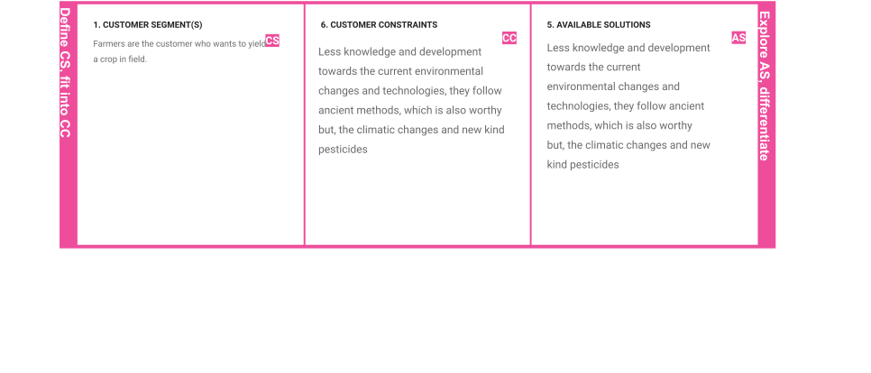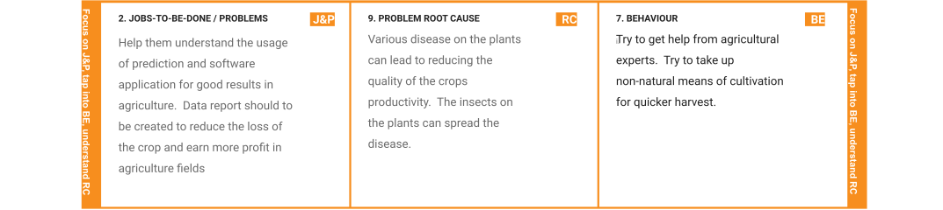

|  |  |  |  |  |  |  |
| --- | --- | --- | --- | --- | --- | --- |
|  | **3. TRIGGERS**  **TR**  Seeing their crops are being infected by disease and facing huge loss in quality. | **10. YOUR SOLUTION**  1.The solution for the problem, creating data reports using past datasets.  2. Creating IBM Cognos dashboard could make  them better understand easily | **SL** | **8.CHANNELS of BEHAVIOR**  **1.Trying to use pesticides and fertilizers that increase gain but cause harm.**  **Irrigation channel changes.** | **CH** |  |
| **4. EMOTIONS: BEFORE / AFTER EM**  Before : Most of the farmers in India have Stress,  Losing Self Confidence  . After : Gain of Self Confidence. |